Integration.py

1. Initialize the model architecture

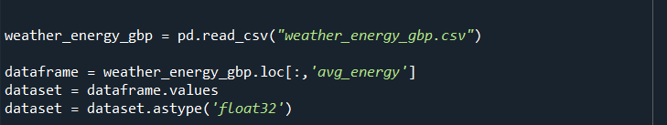

1. Puts the 7 days of input data into the model (Note the multiple ‘7’ in the code)

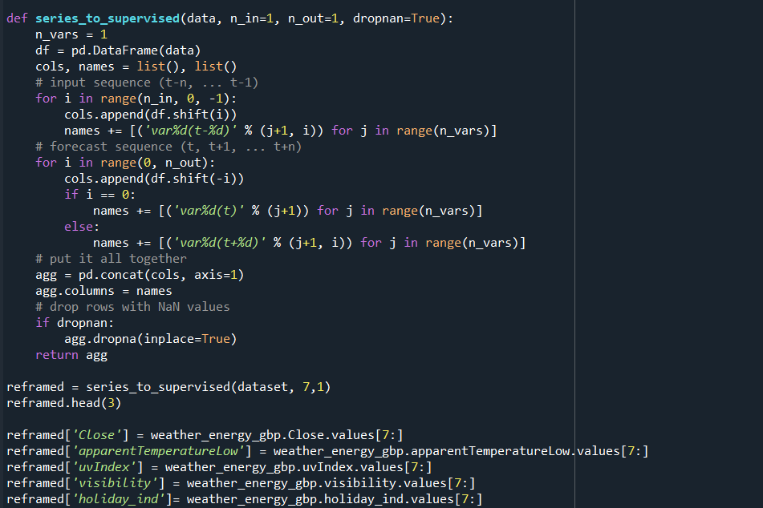

1. Format the values to prepare to input them

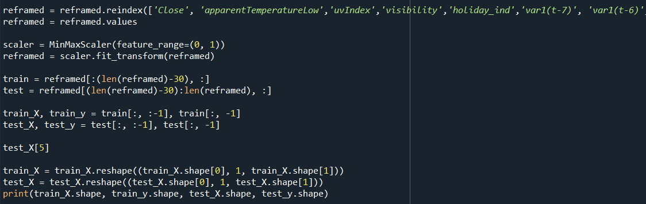

1. Load the weights from the h5 and json files

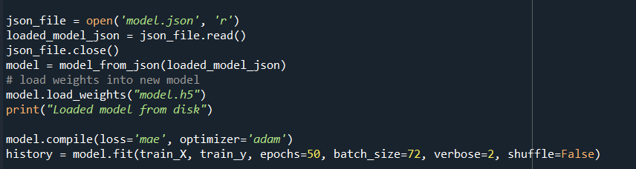

1. Format the output

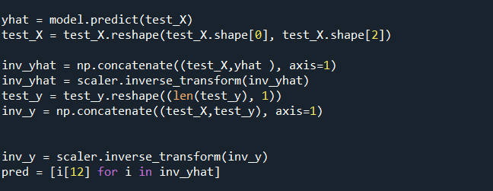

1. Return the model's predicted demand

